Project Design Phase-I
Problem – Solution Fit Template

Date | 31 January 2026
Team ID | LTVIP2026TMIDS28502
Project Name | Visualizing Housing Market Trends: An Analysis of Sale Prices and Features using Tableau
Maximum Marks | 2 Marks

Problem – Solution Fit Template:
The Problem–Solution Fit for this project focuses on identifying the challenges faced by students, data analysts, and stakeholders when working with large housing datasets and providing an effective visualization-based solution using Tableau. Raw housing data stored in CSV format contains numerous records and attributes such as sale price, renovation status, house age, and structural features. However, analyzing such data directly from tables or spreadsheets makes it difficult to identify patterns, trends, and meaningful insights.
Purpose:
- Solve the problem of interpreting large and complex housing datasets by providing interactive visual dashboards and visualizations using Tableau.
- Improve data analysis efficiency by enabling users to identify housing trends, renovation impact, and feature-based comparisons quickly and accurately.
- Enhance user understanding and communication of housing market insights through clear visual representations and structured dashboard design.
- Increase accessibility and usability by publishing dashboards to Tableau Public and integrating them into a web application for easy access and demonstration.
- Provide a scalable and flexible visualization solution that can be extended with additional datasets, new visualizations, and advanced analytics features in the future.
Template:
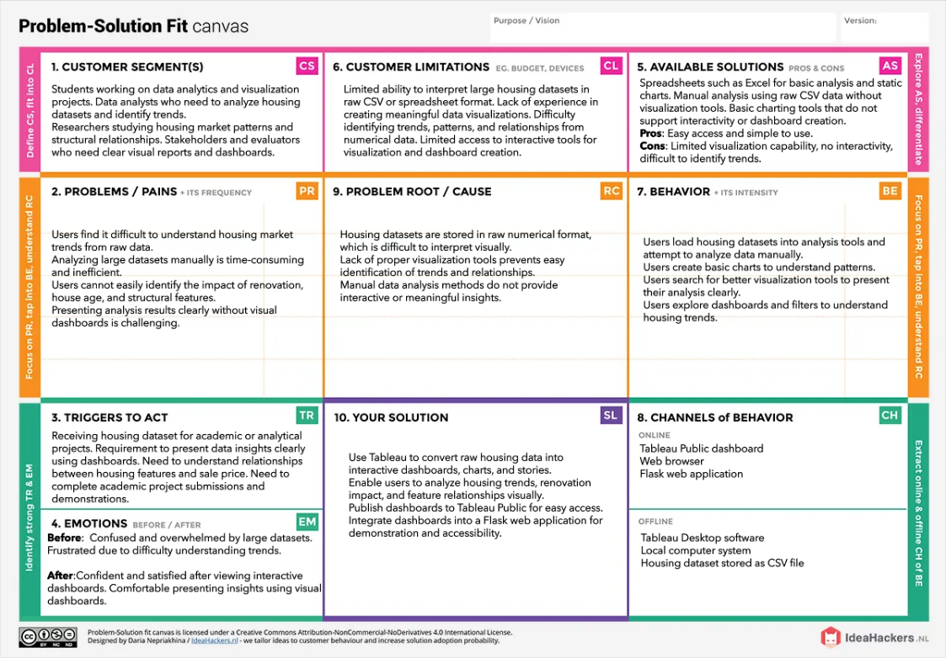
References:
https://medium.com/@epicantus/problem-solution-fit-canvas-aa3dd59cb4fe

